- 1000 x 1000 px Original size of image

- 60 x 60 in Bb (what it gets resized to show as a thumbnail in BbComms in the school's settings:

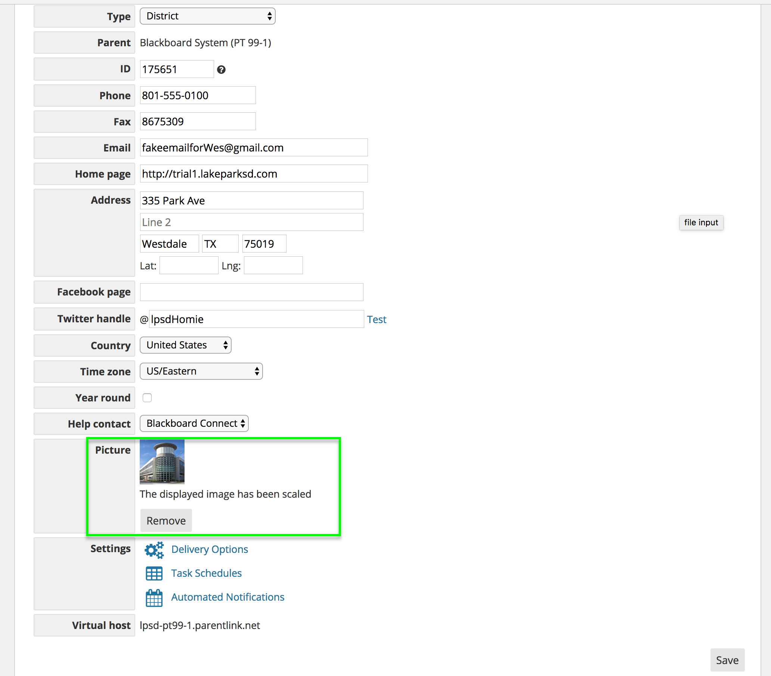

- 146.19 x 146.19 (the size it ends up in our new staff dir in WCM):

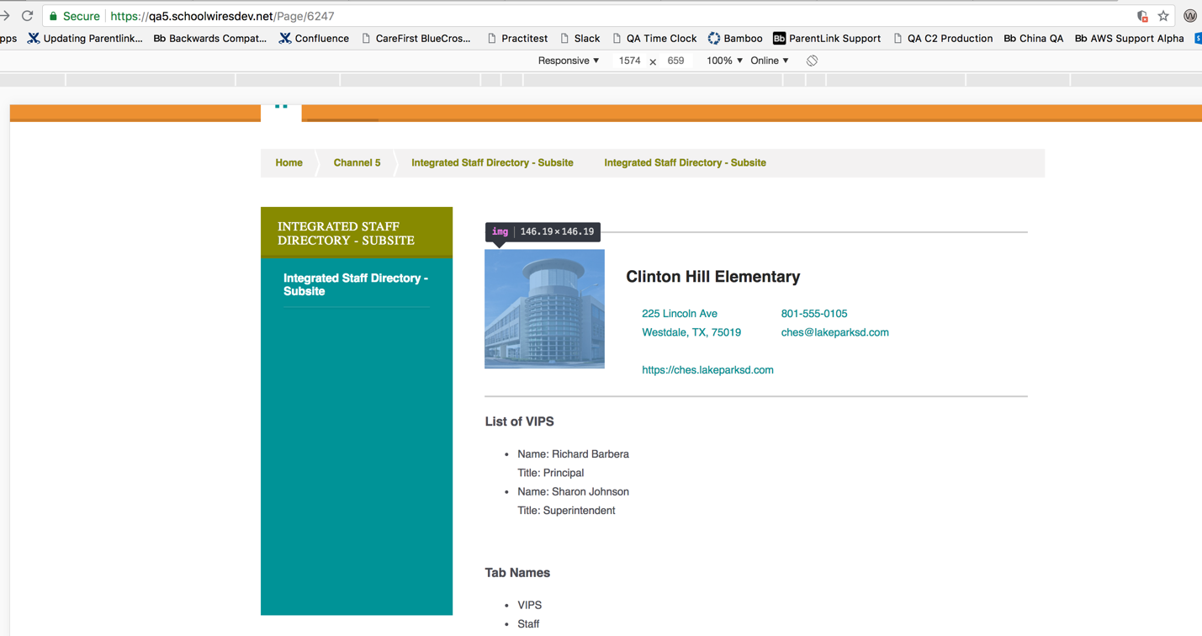

Responsive view:

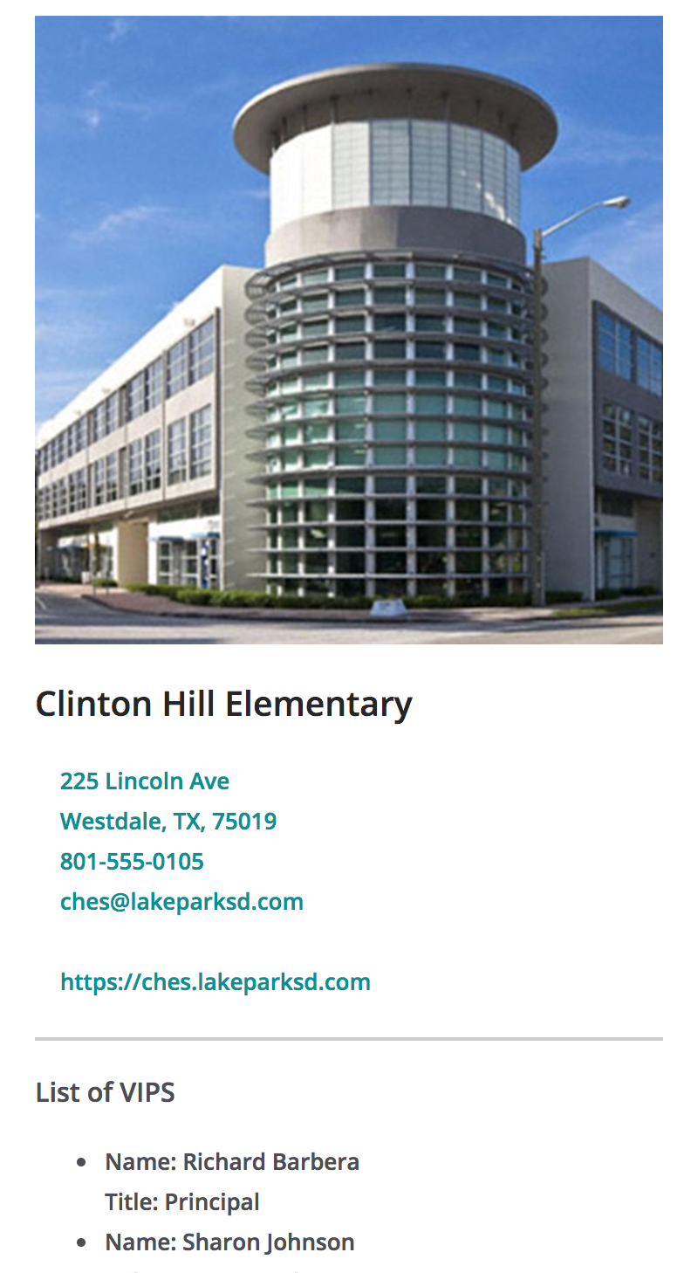

--------------------------------------------

- 500 x 500 original size

- 60 x 60 in bbcomms (no screen shot)

- 146.19 x 146.19 in staff dir:

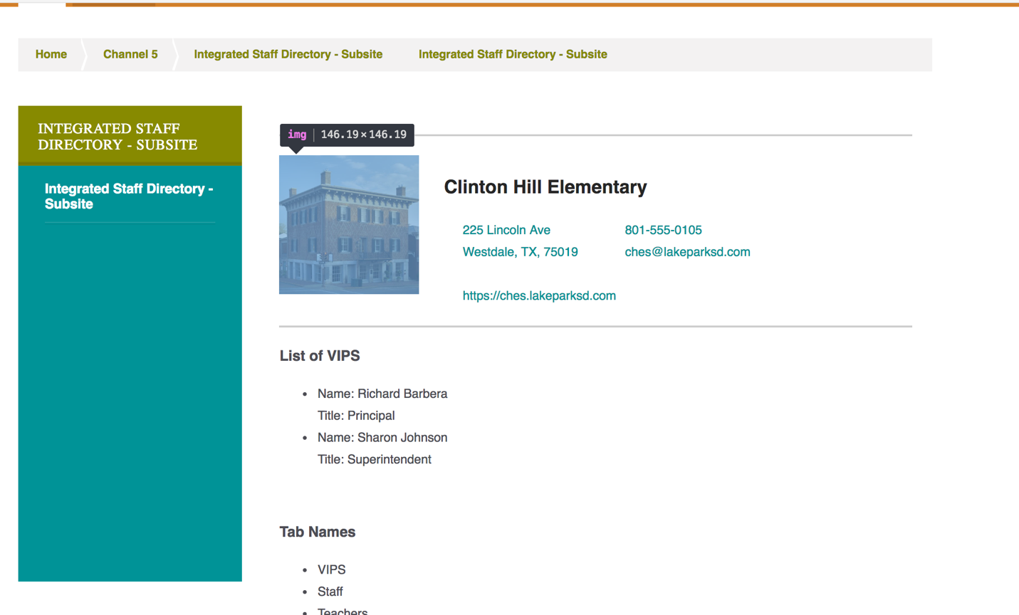

 Responsive view:

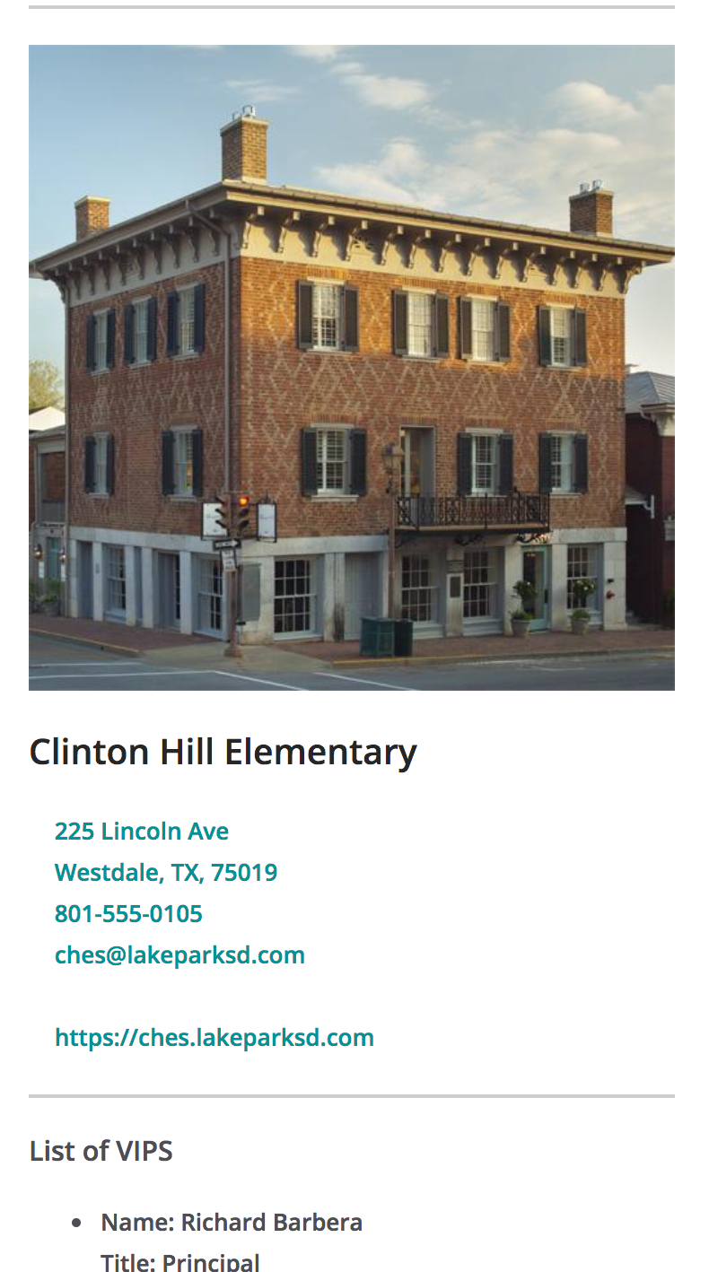

---------------------------

- 2300 x 1169 Original size

- 118.14 x 18 Bb (no screen shot)

- 146.19 x 74.23 WCM:

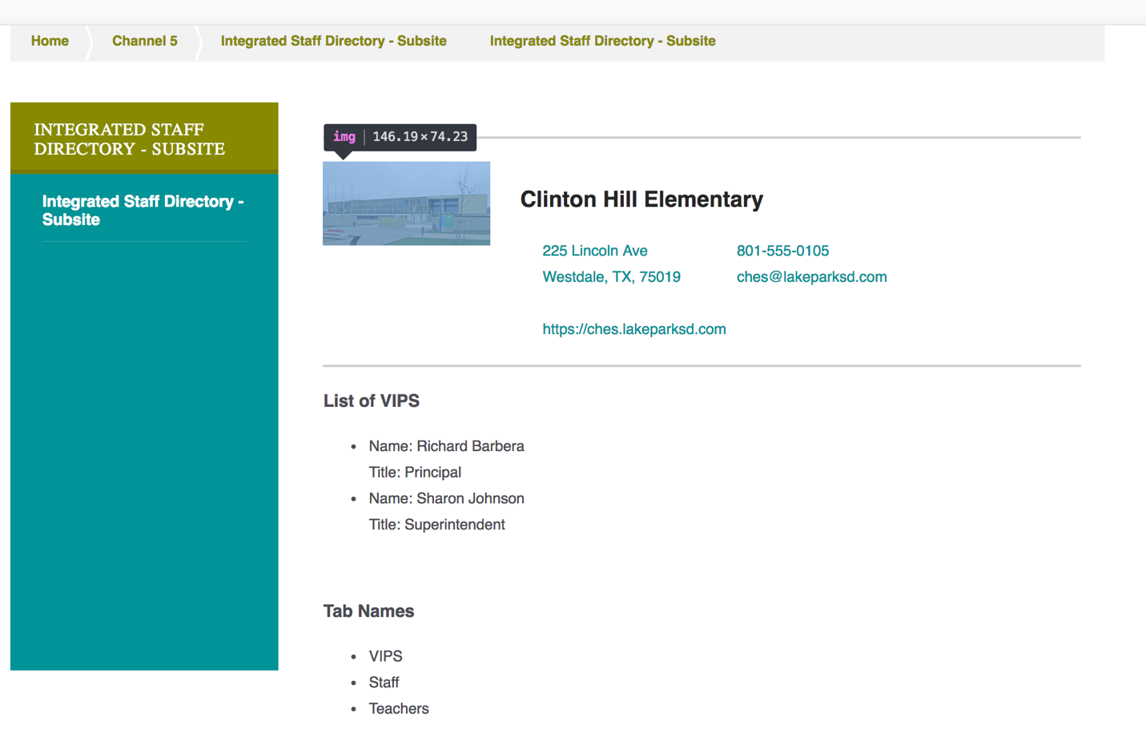

 Responsive View:

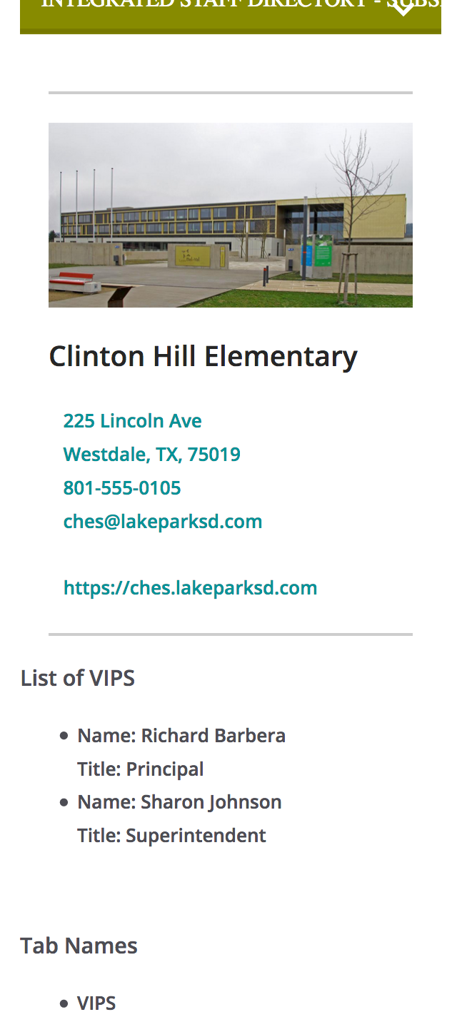

-----------------------------

929 x 1024 Original (almost like portrait mode)

54.42 x 60 Bb (no screen shot)

171.59 x 189.14 WCM:

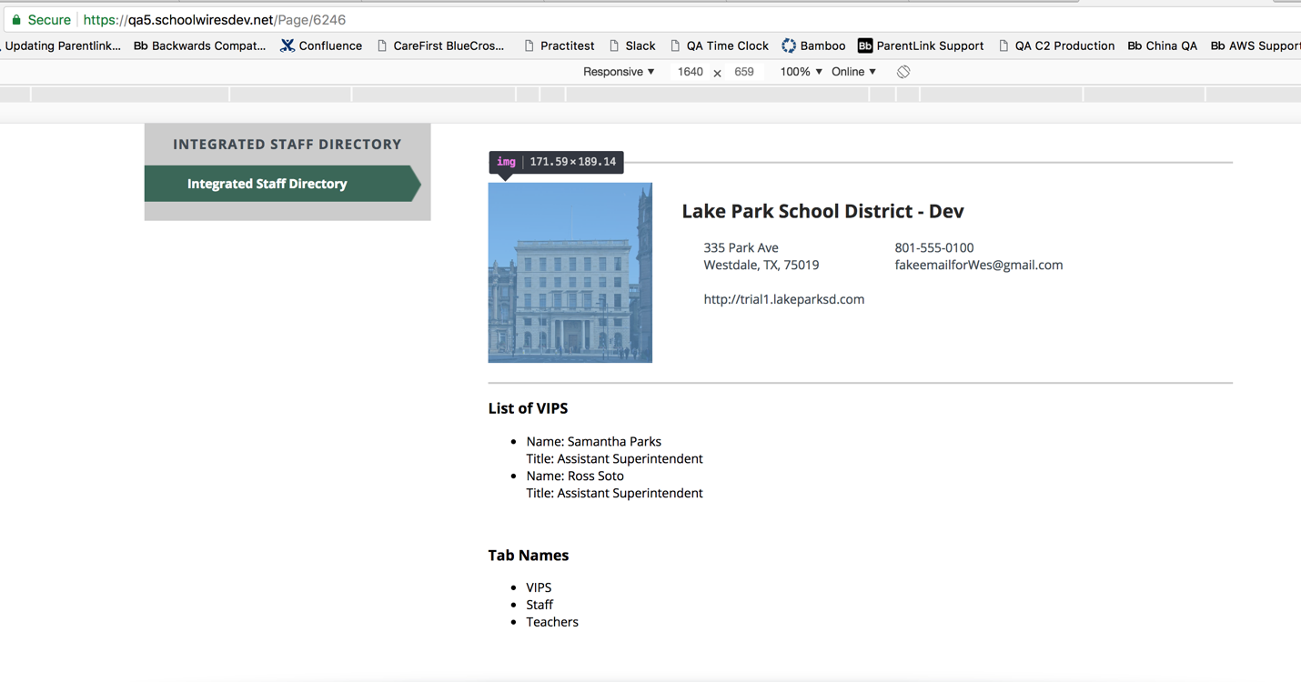

Responsive view:

