**Users PRD**

**Note:** It is strongly recommended that, from a marketing and user-experience standpoint, this section of the portal be titled “users”.

**Definitions**

**Client.** When an organization enters into a contractual relationship with AES to receive a service, the organization is known as a client. A portal client defines the scope for users.

**Monitored location.** A pinpoint location actively monitored by professional AES meteorologists is known as a “monitored location”, in contrast to a “place”, “region”, or (in later phases) “custom region”, which normally are a geographically larger area.

This pinpoint monitored location that is a street address of something like a store may be supplemented in our most popular services by three other definitions for monitored locations:

* pre-defined geographic areas, such as a service footprint or DOT region
* segments, such as highways or pipelines.
* moving assets, where the warning follows the phone or other mobile device wherever it is carried by crews in the field

All are still collectively referred to as monitored locations.

Services typically involving monitored locations include SkyGuard, SWS, HRHW, some hurricane services, public warnings, and local storm reports.

In all phases, a list of monitored locations is created by AES when the client is initially set up in the portal. In Phase 1, monitored places are selected only via a contracting process outside the portal and are not changeable, even by an authorized user, in the short term. This may be relaxed in conjunction with an e-commerce capability in a later phase.

**Contact.** Many client service contracts involve the push delivery of information from AccuWeather, rather than only the pull access of information from the portal by client personnel. An example is a client who buys SkyGuard warnings for a monitored location. Since this service envisions push delivery, one or more contacts must be defined.

A contact is therefore any target of information delivery by any means – a portal user, the client employee who sits beside a particular fax machine, etc. While it is anticipated that the vast preponderance of clients in the future will receive push information through the portal, not all clients will choose the portal as their only contact method. For example, a client who wishes warnings to go to an employee in the field carrying only a feature phone (rather than a smartphone capable of viewing the portal) might choose SMS delivery as the only contact method for that particular employee.

The portal will provide the ability to create and maintain contacts of all types, regardless of how they receive information.

**User.** A ‘user’ is a person with with a client who receives information through the portal or via other methods. Users are distinguished by the fact that, in addition to any other contact methods by which they may receive information, they have a logon ID, password, and authorization level (viewer, superuser, client administrator, AccuWeather administrator, cf. PRD section 27.6) which allow them to access the portal.

All users are contacts, but all contacts are not users. A contact is a user only if he/she has logon credentials.

**Location set.** A grouping of one or more monitored locations is a ”location set”. This is different from the “default place”, which may, but need not, coincide with a monitored location.

Locations sets are created by an authorized user (typically the client administrator). For efficiency purposes, this will typically be done before creating any other users. If no location set is specified, the location set defaults to “ALL” monitored locations.

**Role.** One of the most fundamental concepts of the portal is that what a user can see and do is a function of their location within their organization. This location is characterized by horizontal and vertical dimensions.

* What a contact will see is a function of their horizontal position – their silo — in their organization. A member of Merchandising sees different material than a member of the Emergency Response Center.
* What a user can do is a function of their vertical location in the organization hierarchy. A DOT supervisor is the one who determines what his snow plow driver staff will be viewing. All the snow plow drivers view what the supervisor has made available to them.

In the portal, the concept of “roles” can be used to express both types of contrasts.

A “role” is a client-defined classification of the placement of a contact within the client’s organization or operational hierarchy. Examples of roles may be “emergency response” vs “marketing” or “parks maintenance” vs “snow removal” (examples of definition by horizontal silo placement) or “region manager” vs “store manager” (examples of definition by scope of responsibility, or vertical placement.)

Roles are created by an authorized user (typically the client administrator). For efficiency purposes, this will typically be done before creating any other users. If no roles are specified, the role for all contacts defaults to “ALL”. Each use can have only one role.

**Workgroup.** The concept of a workgroup, which appeared in some earlier documentation, has been superseded by the intersection of a location set and a role. For some purposes, a role may be identical to the earlier workgroup concept (ie, the “marketing” role superseding the “marketing” workgroup) but in other cases the concept of role expresses a placement in a vertical hierarchy, as in “supervisor” role vs. “driver” role. Where a workgroup was something like “emergency response team, Ford plant #38”, that concept is now expressed as the intersection of the roles “emergency response team” and the location of plant #38.

**Functional requirements**

The concepts described above require dialogs for the following activities:

* Create/edit/delete location set
* Create/edit/delete role
* Create/edit/delete contact/user
* Associate role with contact
* Associate location set with contact
* Assign authorization levels to users. (Because contacts cannot access the portal, they do not have and cannot use authorization levels.)
* Edit authorization levels of users

In addition to a body of information that must be associated with each contact to support the can see/can do concept, there is additional information that is needed for the contact process. Therefore, the information associated with each contact will include at least the following. In this list, it has been indicated whether the information is required or optional.

* Contact first name (required)
* Contact last name (required)
* User logon ID (required if contact is also to be a user) – This is an email address in the form dsmall1@ford.com that includes a domain (ford) and top-level domain (com) as well as the user name, as obtaining the information at logon is the only way that the portal is aware of the user’s domain.
* User password (required if contact is also to be a user)
* User authorization level (required if contact is also to be a user) – Chosen from the options Viewer, Superuser, Client Administrator, AccuWeather Administrator. See PRD 27.6. The default is Superuser.
* Contact location set (required) – Chosen from drop-down list of location sets previously defined for the account. The default is All.
* Contact role (required) – Chosen from drop-down list of roles previously defined for the account. The default is All.
* Contact time zone (required) – Chosen from a drop-down list to reduce data entry errors.
* Contact email address (optional, but at least one contact method must be defined for each contact.)
* Contact SMS phone number (optional, but at least one contact method must be defined for each contact.)
* Contact fax number (optional, but at least one contact method must be defined for each contact.)

It is anticipated that client organizations may well wish to store additional information with a user – such as job title, office phone, cell phone, home phone – to facilitate their own contacts with their colleagues in an emergency, as in when viewing the results of a query about locations in the path of a hurricane. We need to resolve whether and how this capability will be offered and whether it has additional pricing associated with it. Therefore, this capability has not been shown on the wireframes below.

The user and contact tools currently included in the dev and sandbox prototypes on the one hand do not make provision for capturing and storing all of this essential data, and on the other hand currently require duplicate entries. A set of wireframes that is both parsimonious and complete is proposed below.

**Sidebar menu structure**

The upshot of current discussions is to modify the previously agreed organization of the Settings section is shown in Michelle’s document “Menu Tree Graphic Site Map_07292014.xlsx”, to appear follows:

Settings

Users and contacts

Manage users and contacts

Manage location sets

Manage roles

Manage dashboards

Alerts

Notifications

Places and regions (was “Locations”; changed as a result of 8/21/14 group

decision replaces selector on each data page)

Procedures

Preferences

AES tools

This would also partially supersede the earlier document “sidebar items 6 9 14.xlsx”, and what is currently documented in section 22.4 of the PRD.

Note that in this menu, “manage” is proposed as a euphemism for “create/edit/delete” to save space in the menu.

There is an interesting UI question implied in this menu. Managing location sets and roles needs to be done first. But managing users and contacts will be done more often. Which should be listed first in the menu?

**Create/edit/delete location set**

The first dialog seen upon entering this menu item is like this.

This may be a very tall page, since accounts like Lowe’s may have over a hundred locations sets (market areas plus regions.) It presumably scrolls and has controls for how many locations to show at time.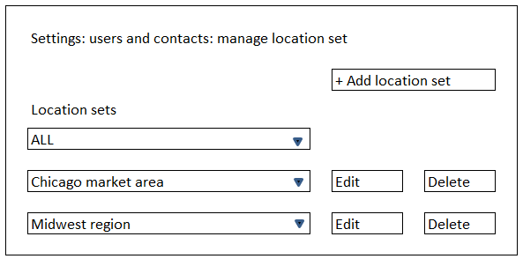

The location set “ALL” is always present and can never be edited or deleted. For over 40% of our accounts, “ALL” will be the only location set they will ever need.

The contents of a location set may be quickly inspected via the drop down area. (See the example at left.)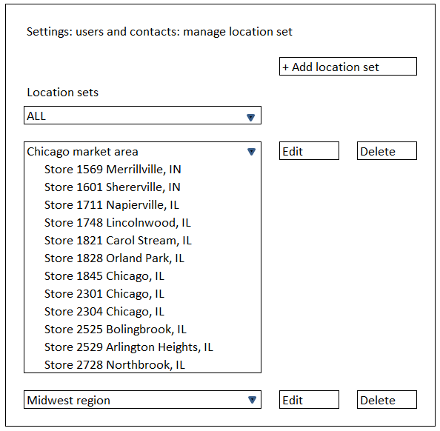

If the authorized user clicks Add Location Set, a blank form comes up that looks like the example on the next page. If they click Edit for a particular location set, the same form comes up, but it is filled out with the information about the currently selected location.

For the adding of a location set to be practical for a client like Ford, with 50 plants, the monitored locations must be available as a drop-down. For it to be practical for a client such as Lowes, with 1700 possibilities, there must also be a search function. (The rejoinder that “AES will set it up for them” is not a solution. We will need such tools ourselves!)

Note that I have heard nothing about placing a limit on the number of either monitored locations or the members of a location set. Therefore, as shown here, we need scroll bars on both fields. 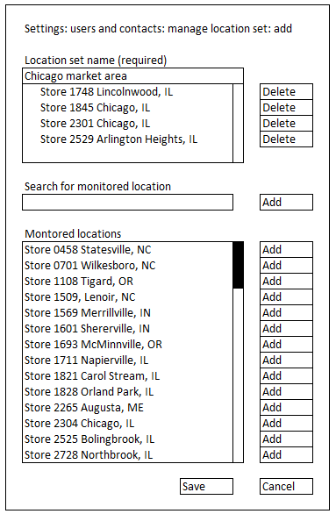

Note the scroll bars that will be required to handle the large number of locations at some accounts.

**Create/edit/delete role**

In the setup flow, roles either need to be created prior to creating users, or all users must be allowed to default to ALL. (This means all users receive all warnings, which is likely to be exactly what about 40% of our clients – the single-site SWS folks -- will want to have happen anyway.)

The first dialog on entering this section could be: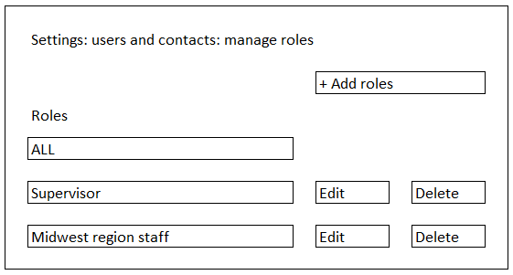

If the authorized user clicks Add Role, a blank form comes up that looks like the wireframe at the left. If they click Edit Role, the same form comes up, but it is filled out with the information about the currently selected role.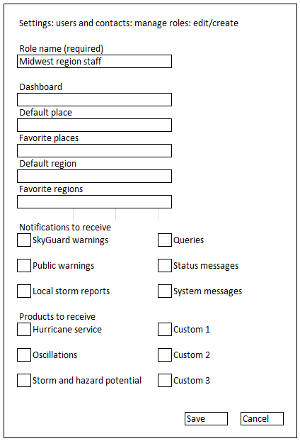

The number of roles at some accounts may be quite large. At Lowe’s, for example, it apparently will be on the order of 1700 stores + 90 market areas + 13 regions + a number of headquarters functions + some number of levels of hierarchical roles. This again underscores the need for a bulk upload capability.

In the Create/Edit Roles dialog, the “dashboard” field is a drop-down list of currently existing dashboards.

The “default location” and “favorites” use the location manager tool. The specification of default and favorite regions control things like the default view on infographic maps. This could be especially useful for customers who have paid to have many custom regions based on their organizational structure.

The “notifications to receive” and “products to access” areas are check boxes (not radio buttons; ie, not mutually exclusive). These allow the roles to be configured in terms of the information they wish to see.

The question of the categories in this part of the dialog is ripe for further discussion. The entries in the wireframe above now reflect primarily the parts of the portal that we have tentatively identified as extra-charge items, including custom products. But presumably if the account did not want a particular role to see them, they did not buy them, and this part of the dialog would therefore be moot. So, is this the most useful way to allow the administrators to manage information? Is there a need to control other, presumably non-optional areas, such as history? (In other words, should this set of check boxes look very much like the first couple levels of the main menu?) A goal of the portal, we have always said, is to offer each person only the information of interest to them. How granular do we want this power to be?

**Create/edit/delete user**

The basic dialog for creating a user appears at the left. This is similar to a prototype Nick has already created.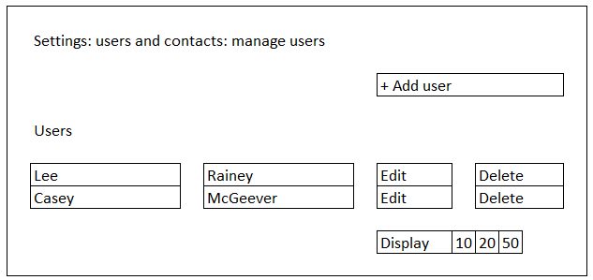

The information stored about any one user is quite voluminous – too much so to display across a page. It is suggested that the edit or create buttons both lead to a dialog in vertical format, as shown below.

As usual, if the authorized user clicks Add User, a blank form comes up that looks like the one at left. If they click Edit User, the same form comes up, but it is filled out with the information about the currently selected user.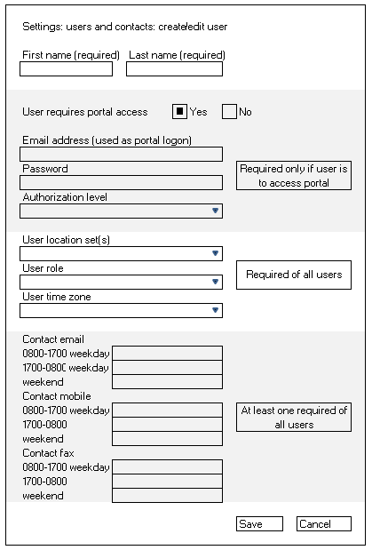

There is a radio button for portal access with a default of ‘yes.” If this button is left at yes and some part of the login information is left blank, an error message is issued when “save” is clicked.

User location, user role and user time zone are selected from drop-down menus. The contents of the user location set and user role menus are user-defined via the location set and role dialogs described earlier.

A user may have only one role and one time zone. (They may have only one role because it determines their default dashboard and default place.) They may be members of multiple location sets. Also, a monitored location is itself a valid entry for the location set. This allows a central emergency manager could see all warnings, while the staff of each store would see only their own warnings.

Because all users are contacts but not all contacts have portal access, the contact section must be filled out in every case. We need to determine to what extent it needs to be completed. The fields shown match what currently appears in the master PRD. There are other reasonable ways this could be structured.

The number of users at some accounts may be quite large. At Lowe’s, for example, it may exceed 5,000 (multiple managers x 1700 stores). It is not reasonable to expect that the customer will key in a list of this size manually . . . nor is it reasonable to expect that, if AES does this for the customer, we will do this manually. Therefore there is a need for an upload capability.

There may be an economy-of-scale opportunity here. The portal has the need to upload a number of types of bulk data – location aliases, user information, procedures, workgroups, and potentially, in later phases, information associated with custom regions. A bulk upload dialog for the portal, as proposed in the document “page templates.xlsx” of 3/30/14, would be an efficient way to do this.